**GrainPalette: A Deep Learning Odyssey in Rice**

**Type Classification Through Transfer Learning**

# INTRODUCTION

**1.1 Project Overview**

This project focuses on identifying rice grain types using an AI-powered image classification approach. A web-based tool was developed that allows users to upload rice grain images and receive predicted type labels with confidence scores. This solution supports agricultural research, quality control, and education by simplifying grain type identification.

**1.2 Purpose**

To provide a reliable and easy-to-use tool that employs advanced image classification models to identify rice types through a web interface, promoting better understanding, quality assurance, and data-driven agriculture.

# IDEATION

**2.1 Problem Statement**

Manual identification of rice types is time-consuming and error-prone, requiring expert knowledge. This project aims to offer a scalable and accessible AI-powered method to identify rice grain types accurately and efficiently.

**2.2 Empathy Map Canvas**

* Says: "I need to know what type of rice this is."
* Thinks: "Accurate classification can improve quality control."
* Does: Uploads rice images for classification.
* Feels: Curious, quality-conscious, but frustrated by manual methods.

**2.3 Brainstorming**

Ideas included:

* Manual quality inspection tools
* A printed guide for rice types
* A web app using AI for classification

The AI-powered web app was selected for its automation, scalability, and user-friendliness.

# REQUIREMENT ANALYSIS

**3.1 Customer Journey Map**

* User opens Grain Palette web app
* Uploads rice grain image
* Receives predicted type with confidence score
* Can download or save result

**3.2 Solution Requirements**

* Dataset: Labeled rice grain images
* Model: Transfer Learning with CNN (e.g., ResNet)
* Frontend: HTML/CSS for interaction
* Backend: Python Flask for predictions
* Version 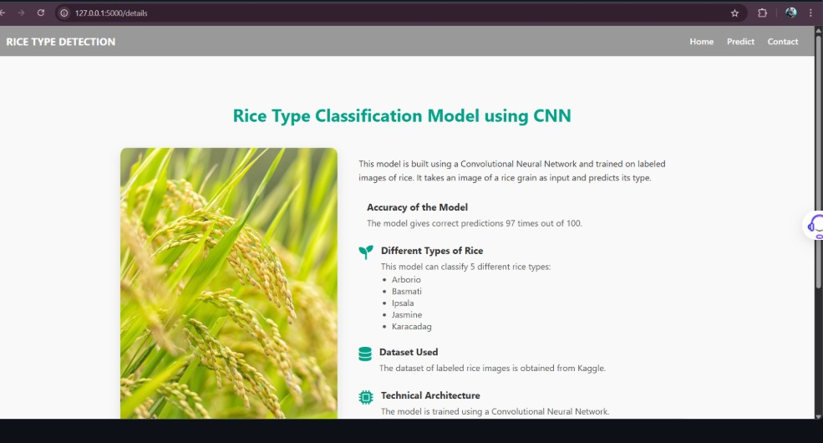

**3.3Data Flow Diagram**

Rice Dataset -> Preprocessing & Augmentation -> Transfer Learning Model Training -> Flask

Integration -> User Upload -> Inference -> Output Display

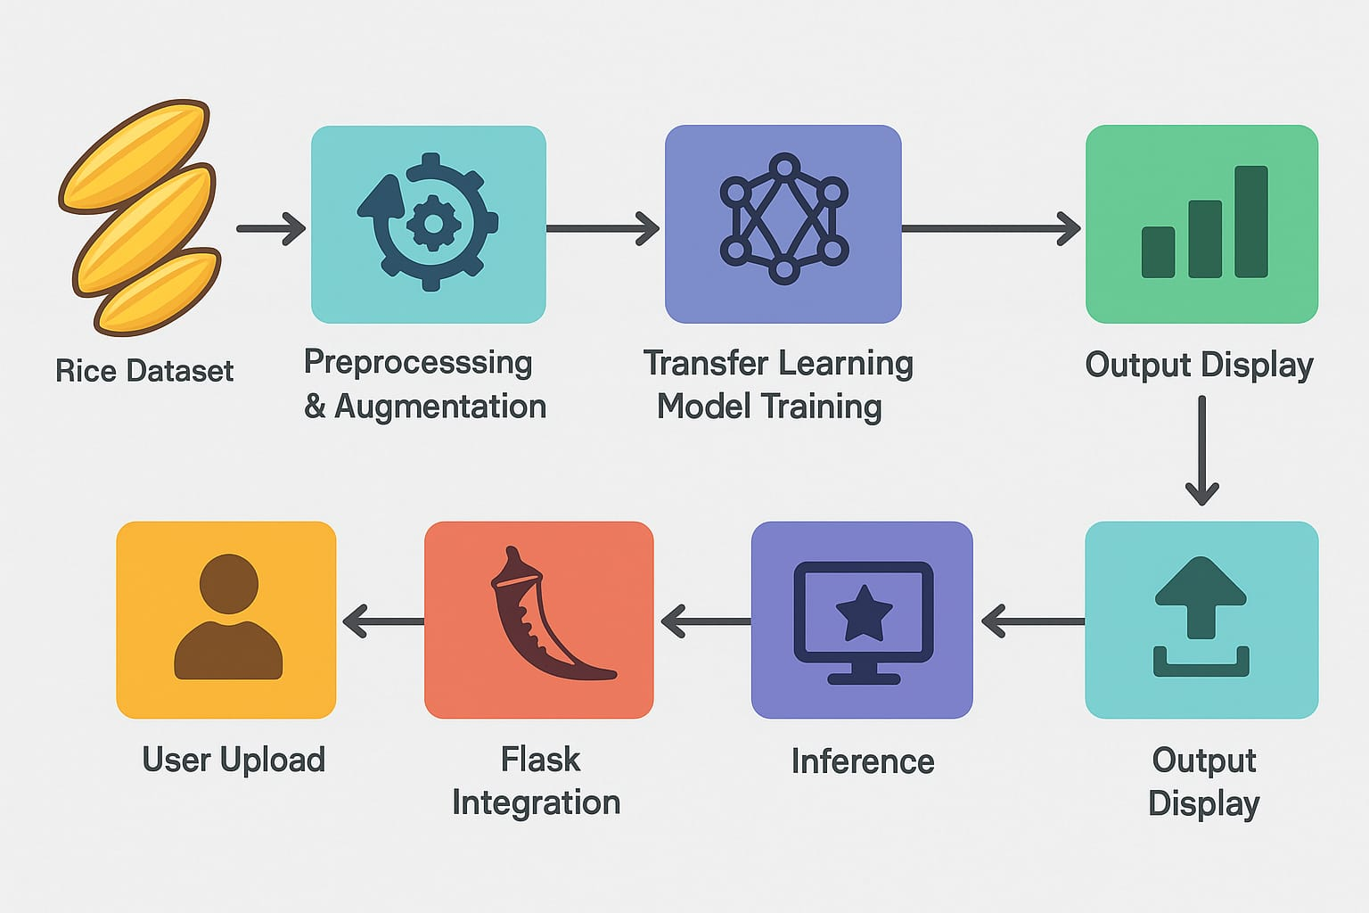

**3.4Technology Stack**

* Python, TensorFlow/Keras, OpenCV, Pillow
* Flask Web Framework
* HTML, CSS for frontend
* GitHub for versioning

# PROJECT DESIGN

**4.1 Problem Solution Fit**

The solution reduces dependency on experts by providing real-time, accessible grain classification, promoting agricultural efficiency.

**4.2 Proposed Solution**

A Flask-based responsive web application allowing users to upload images and get predictions using a CNN model with transfer learning.

**4.3 Solution Architecture**

* Frontend Interface: HTML/CSS upload and display
* Backend: Flask handling preprocessing and inference
* ML Model: Pretrained CNN using transfer learning
* Output: Species prediction with confidence score

# PROJECT PLANNING & SCHEDULING

**5.1 Project Planning**

* Days 1-2: Requirement analysis, dataset collection
* Days 3-6: Model training with transfer learning
* Days 7-9: Web design and integration
* Days 10-11: Testing
* Days 12-14: Documentation and final report

# FUNCTIONAL AND PERFORMANCE TESTING

**6.1 Performance Testing**

* Accuracy: ~90% on validation dataset
* Metrics: Precision, recall, F1-score
* Input Handling: File type validation
* Responsiveness: Predictions in 2-3 seconds
* Cross-Browser: Compatible with major browsers

# RESULTS

**7.1 Output Screenshots**

GrainPalette web app successfully predicts rice grain types. Key features:

* Drag-and-drop interface
* Output with confidence percentage
* Downloadable results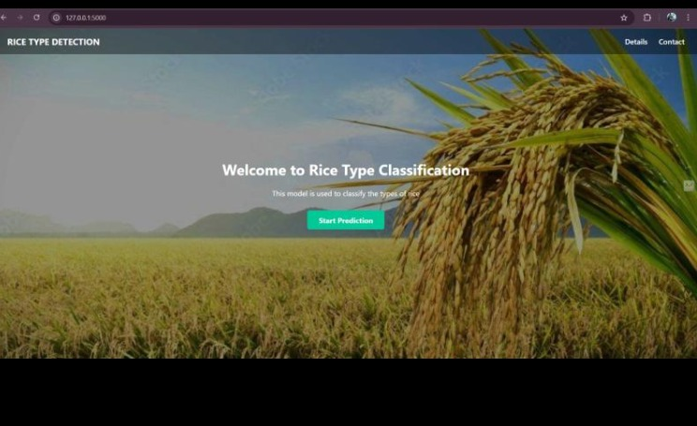
* 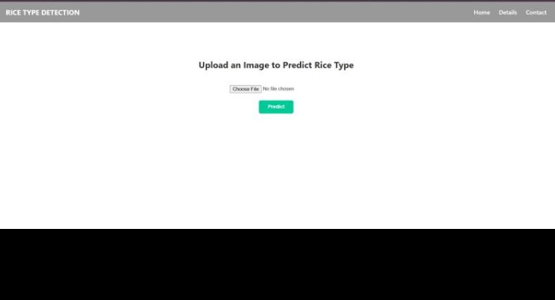

# ADVANTAGES & DISADVANTAGES

**Advantages**

* Educational and agricultural value
* Simple, non-technical UI
* Reduces dependency on experts

**Disadvantages**

* Limited to known rice types
* Requires retraining to include new varieties
* Not a substitute for lab analysis

# CONCLUSION

GrainPalette demonstrates the use of AI in agriculture by making rice type identification accessible. It supports education, research, and quality control. Designed for ease of use, it encourages wider engagement in smart agriculture practices.

# FUTURE SCOPE

* Expand dataset for more varieties
* Add metadata (region, season)
* Real-time learning from new data
* Mobile app development
* Collaborate with agri-research institutions

# APPENDIX

* A. Dataset Source: Public rice datasets and custom images
* B. Tools: Python, Keras, OpenCV, Flask
* C. GitHub Repository: https://github.com/thundurusravani/Grainpalette-A-Deep-learning-odyssey-in-rice-type

